STUDENT’S VERSION

SAMPLE ITEM

PUBLICATION 2022
Ministry of Education, Youth & Information
Programme for International Student Assessment (PISA)
Ass Assessment

STUDENT’S VERSION
Every Child Can Learn, Every Child Must. Learn

Foreword
The Organization for Economic Cooperation and Development (OECD) Programme for International Student Assessment (PISA) is a study that compares and examines student performance in mathematical, reading and scientific literacy, conducted every three years. The PISA assessment examines the extent to which education systems are preparing students to meet life’s challenges – to become tomorrow’s workers, to continue learning throughout life, to analyze, reason and communicate ideas effectively.
Administration of PISA 2022 in Jamaica will assess students' science, reading, mathematics literacy and creative thinking. Mathematics will be the focal subject of the 2022 data collection.
This document is a publication of questions released through the OECD’s Programme for International Student Assessment (PISA). The sample test items include questions at each proficiency level for each testing domain (reading, mathematics and science).
The intent of this publication is to illustrate to teachers and students the complexity of the questions as well as the skills required by students to respond to the questions in the various subject domains.

Students can access PISA questions online by using the following link:
https://www.oecd.org/pisa/pisaproducts/pisa-test-questions.htm

Table of Contents
Foreword 2
About the PISA 4
Purpose of this Document 5
Will these items appear on the final PISA assessments? 5
How can teachers administer these questions to their students? 5
Overview of Item Types 6
MATHEMATICS: SAMPLE ITEM #1 7
MATHEMATICS: SAMPLE ITEM #2…………………………………………………………………...8
MATHEMATICS: SAMPLE ITEM #3 10
MATHEMATICS: SAMPLE ITEM #4 11
MATHEMATICS: SAMPLE ITEM #5 13
MATHEMATICS: SAMPLE ITEM #6 15
MATHEMATICS: SAMPLE ITEM #7 18
MATHEMATICS: SAMPLE ITEM #8 19
SCIENCE: SAMPLE ITEM #1 22
SCIENCE: SAMPLE ITEM #2 24
SCIENCE: SAMPLE ITEM #3 26
SCIENCE: SAMPLE ITEM #4 27
SCIENCE: SAMPLE ITEM #5 28
READING: SAMPLE ITEM #1 29
READING: SAMPLE ITEM #2 30
READING: SAMPLE ITEM #3 31
READING: SAMPLE ITEM #4 32
CREATIVE THINKING: SAMPLE ITEM #1 35
REFERENCES ...……………………………………………………………………………………….38

About the Programme for International Student Assessment (PISA)
The Programme for International Student Assessment is a worldwide study by the Organization for Economic Co-operation and Development in member and non-member nations intended to evaluate educational systems by measuring 15-year-old school students' academic performance on mathematics, science, and reading.
Rather than assessing students on particular school curricular, PISA attempts to measure the knowledge and skills that students possess towards the end of their years in school which will enable them to participate fully in adult life. This is done by measuring their performance on ‘real-life’ tasks that are considered relevant for effective ‎participation in adult society and for life-long learning.
First conducted in 2000, the major domain of study rotates between reading, mathematics, and science in each cycle. PISA also includes measures of general or cross-curricular competencies, such as collaborative problem solving. By design, PISA emphasizes functional skills that students have acquired as they near the end of compulsory schooling.

What subject areas are assessed in PISA?
PISA measures student performance in mathematics, reading, and science literacy. In addition, for the 2022 sitting, students’ performance in creative thinking will be measured. Each PISA survey cycle assesses one of the three core subject areas in depth (considered the major or focal subject). For 2022, the major subject will be Mathematics.

How will PISA Tests be administered?
PISA will be administered using computers. Students will be given their unique login credentials to logon to the assessment platform. The items will comprise of a stimulus, which may be in the form of text, diagram, photo, comic, graph, tables etc. The question will follow the stimulus material. Students will be required to respond to the questions using the on-screen interactive tools. The mouse and/or keyboard can be used to access these on-screen interactive tools. Some of the on-screen interactive tools include: drag and drop, select an option, or move a pointer. In some cases, students may be required to type their answers in the spaces provided.
Using a multi-stage approach, the assessments in mathematics and reading are adaptive to each student’s ability level – students start on a common set of items, and then, at intervals, progress onto items of a lower or higher difficulty, based on their previous performance.
For students who will sit PISA, a training exercise will be developed for them in how to use the interactive tools of a computer based assessment platform to respond to questions.

Purpose of this Document
While PISA will be administered via a computer platform, the practice items presented in this document are in paper- based format. This document presents a sample of the items that students could most likely encounter during the PISA assessments. These samples are intended to illustrate the rigor, level of difficulty and complexity of the items that could be used on PISA.

Will these items appear on the final PISA assessments?
The sample items are meant to illustrate the rigor and complexity students may encounter on the PISA assessments. They also show the different types of questions that potentially could appear on the assessments, including: selected-response and constructed response. These items have been released by PISA and are NOT part of the secure PISA assessments.

How can teachers administer these questions to their students?
The sample items are intended to be used as practice items. Mathematics, Science and Reading Teachers can use them as practice items in their regular program of teaching and learning, or they can give them to students as take home assignments. It is important for teachers to give students an opportunity to first respond to the items independently and then have students share their responses with the view of evaluating them against the expected responses. It is important for teachers to provide students with tips in responding to these items. Some students become excited about stimulus material (text, diagrams, comic strips etc.) without paying attention to the specifics. Teachers should share the following tips with students in guiding them to respond to questions:
- Read through the stimulus material carefully
- Underlining key words
- Analyze what the question requires
- Prepare a plan of how to respond to the question

Overview of Item Types
The PISA assessment will be administered as a Computer Based Test. That is, the questions will be viewed in a computer application and students will respond to these questions in the computer application using computer tools. These assessments will include a variety of question types, including:
- Simple multiple choice: require students to select one responses from a set of options
- Complex multiple choice: require students to select one or more responses from a set of options
- Closed-constructed response: require students to produce a single text or numerical response
- Open-constructed response: require students to produce an extended response to the question, usually an explanation

A combination of these item types can be used to assess one item.

Students can access PISA questions online by using the following link:
https://www.oecd.org/pisa/pisaproducts/pisa-test-questions.htm

MATHEMATICS: SAMPLE ITEM #1
IRON-ON IMAGE

Josh designs images for t-shirts on his computer. He prints the images using special paper. The image is then ironed onto the t-shirt. The final image on the t-shirt is a mirror image of the design on the computer.
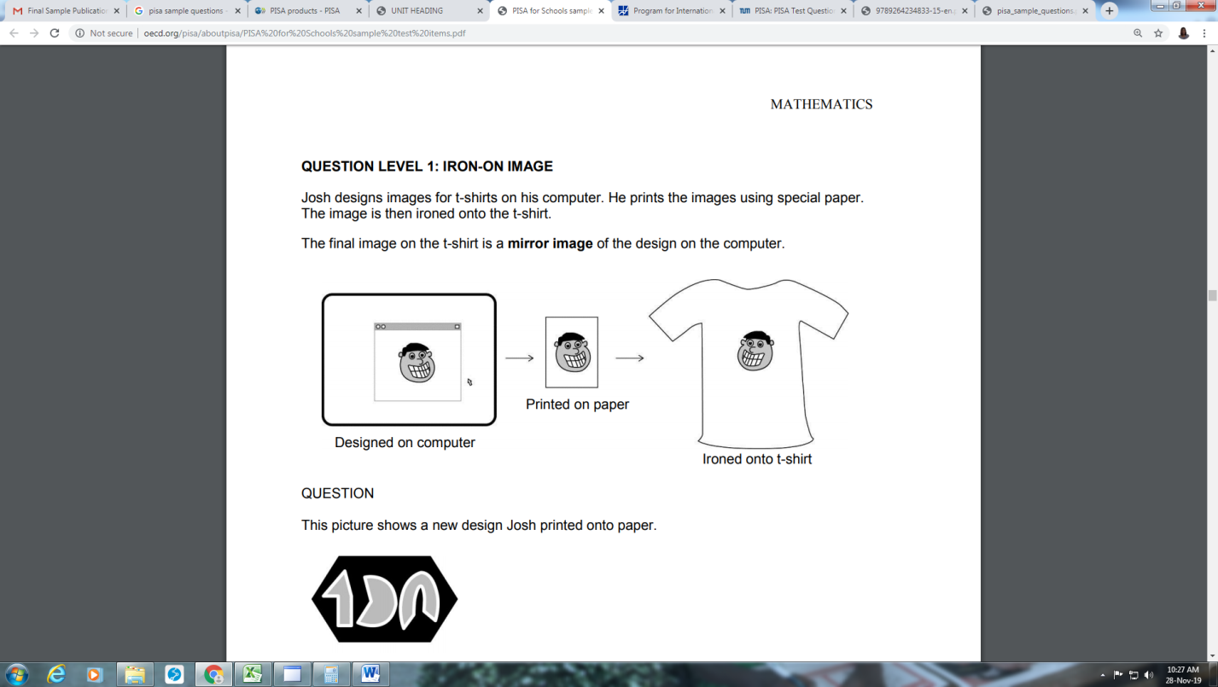

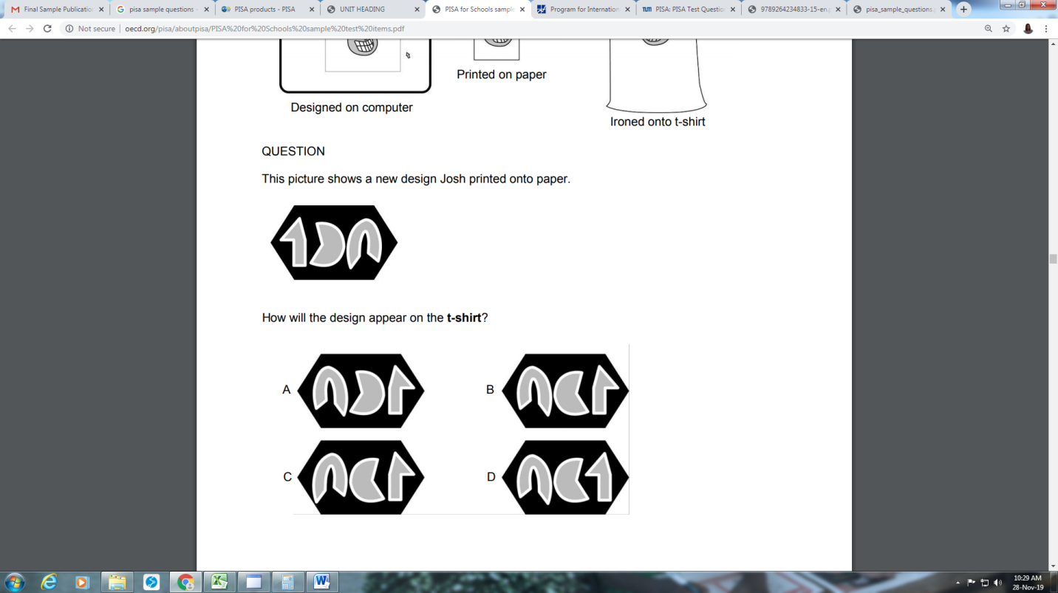
This picture shows a new design Josh printed onto paper

Question: How will the design appear on the t-shirt?
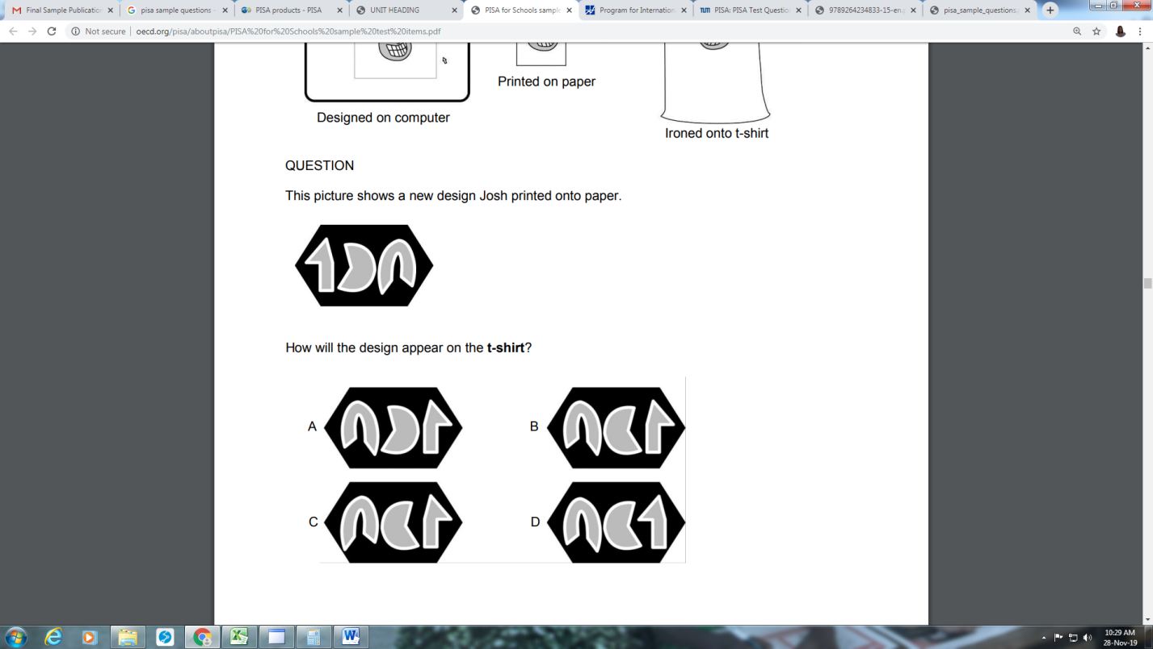

MATHEMATICS: SAMPLE ITEM #2
AGE OF MOTHERS

This graph shows the percentage of births in Zedland for two years (1960 and 2000), according to the mother’s age at the time of birth. For example, in 1960, 16% of the births were to mothers in the 30-34 age group.
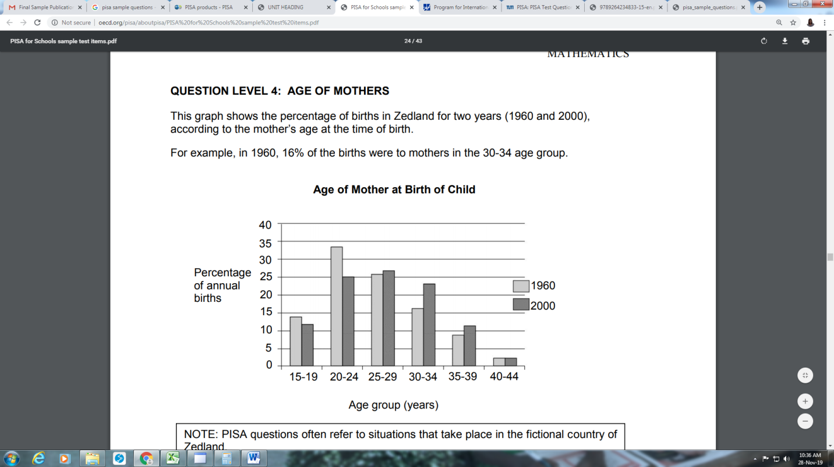

Is each of the following statements about the graph true or false?
Choose “True” or “False” for each statement.
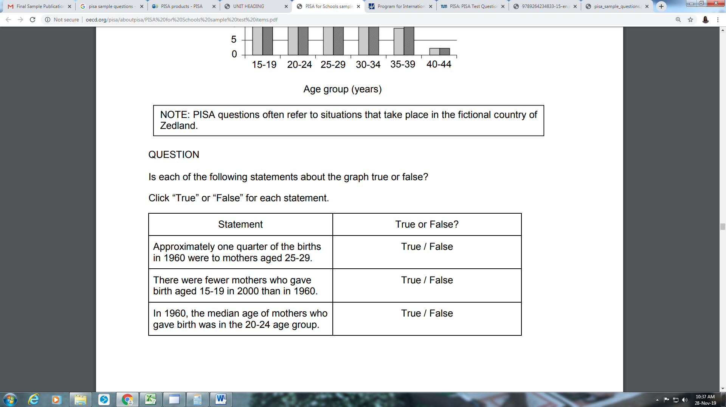

MATHEMATICS: SAMPLE ITEM #3
CHARTS

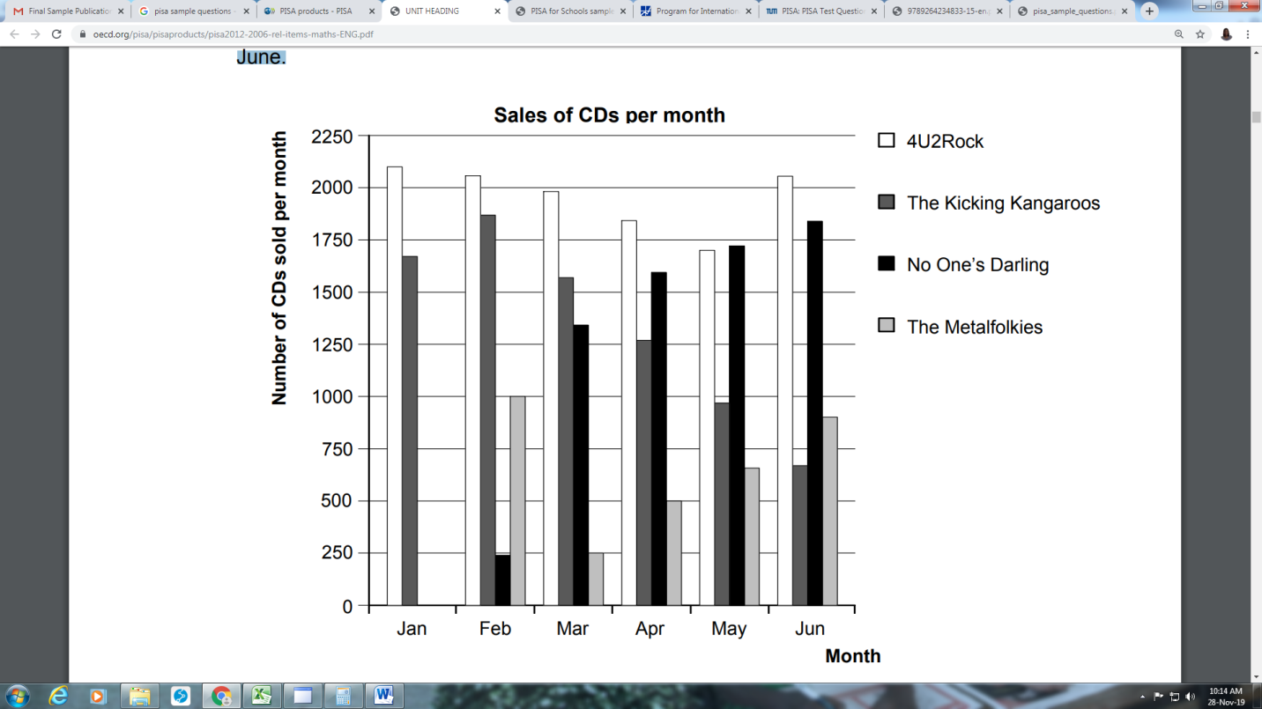
In January, the new CDs of the bands 4U2Rock and The Kicking Kangaroos were released. In February, the CDs of the bands No One’s Darling and The Metalfolkies followed. The following graph shows the sales of the bands’ CDs from January to June.

MATHEMATICS: SAMPLE ITEM #3
CHARTS

Questions
- How many CDs did the band The Metalfolkies sell in April?
- 250 B) 500 C) 1000 D) 1270

- In which month did the band No One’s Darling sell more CDs than the band The Kicking Kangaroos for the first time?
A) No month B) March C) April D) May

- The manager of The Kicking Kangaroos is worried because the number of their CDs that sold decreased from February to June.
What is the estimate of their sales volume for July if the same negative trend continues?
A) 70 CDs B) 370 CDs C) 670 CDs D) 1340 CDs

MATHEMATICS: SAMPLE ITEM #4

APARTMENT PURCHASE

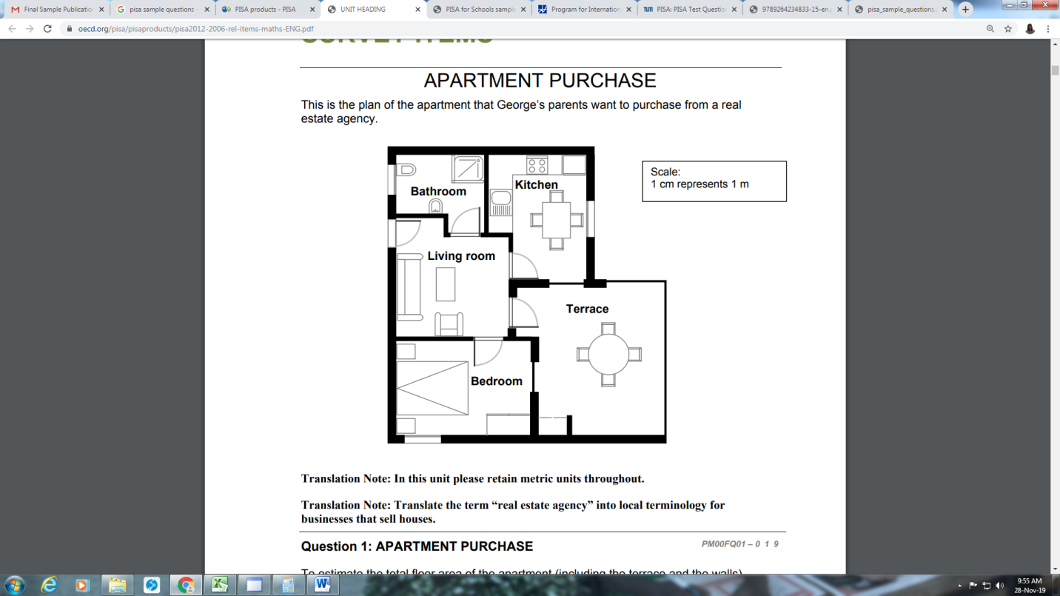

To estimate the total floor area of the apartment (including the terrace and the walls), you can measure the size of each room, calculate the area of each one and add all the areas together.

However, there is a more efficient method to estimate the total floor area where you only need to measure 4 lengths.

MATHEMATICS: SAMPLE ITEM #4

APARTMENT PURCHASE

Question:
- Mark on the plan above the four lengths that are needed to estimate the total floor area of the apartment.

- Make a drawing of the four lengths that are needed to estimate the total floor area of the apartment in the space below.

MATHEMATICS: SAMPLE ITEM #5
DRIP RATE

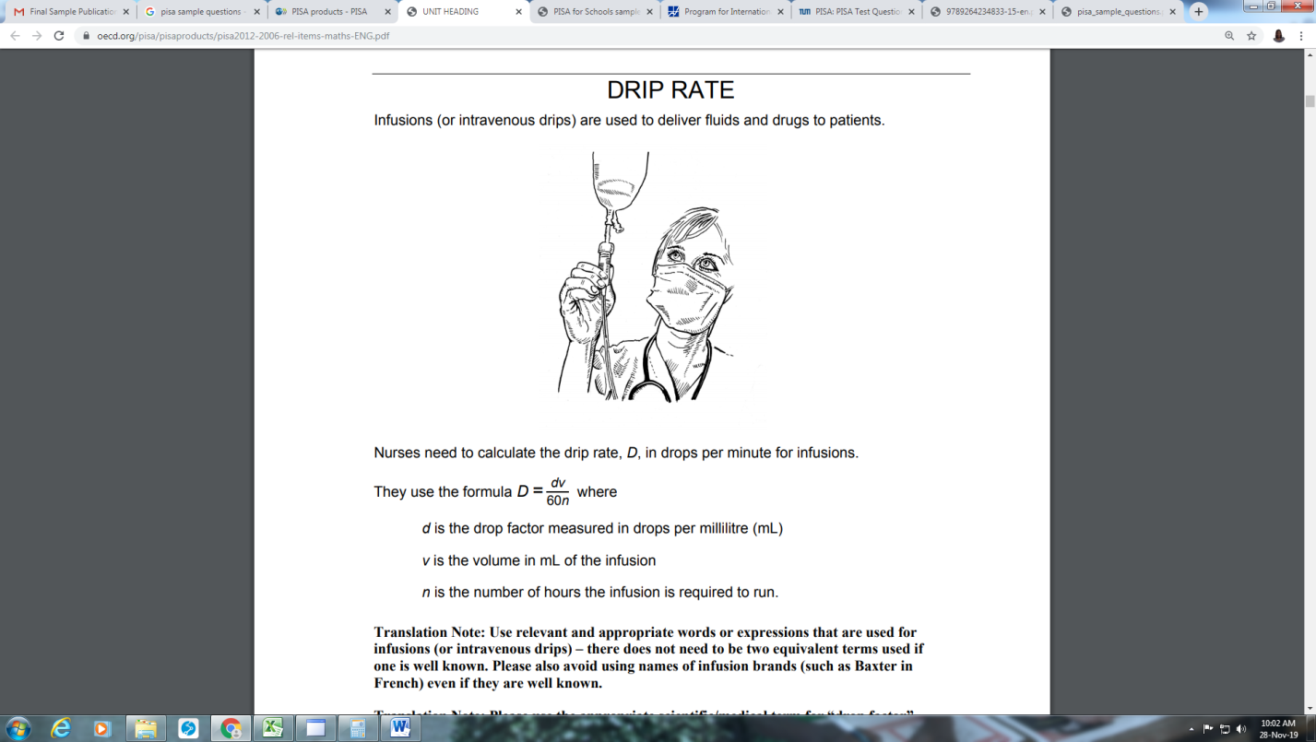
Infusions (or intravenous drips) are used to deliver fluids and drugs to patients.

Nurses need to calculate the drip rate, D, in drops per minute for infusions.

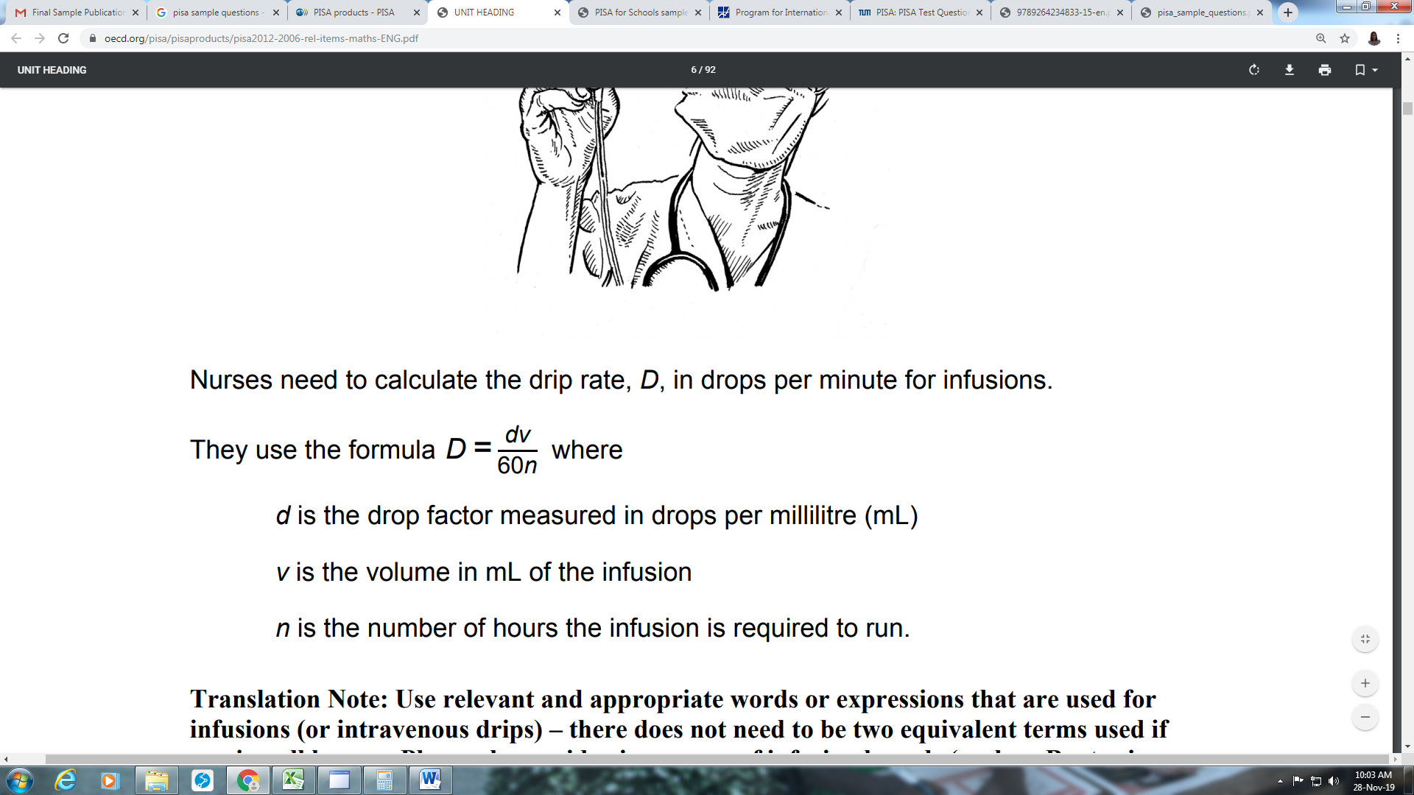
They use the formula where

d is the drop factor measured in drops per millilitre (mL)
v is the volume in mL of the infusion
n is the number of hours the infusion is required to run.

MATHEMATICS: SAMPLE ITEM #5
DRIP RATE

Questions
- A nurse wants to double the time an infusion runs for. Describe precisely how D changes if n is doubled but d and v do not change.

................................................................................................................................... ................................................................................................................................... ...................................................................................................................................

- Nurses also need to calculate the volume of the infusion, v, from the drip rate, D. An infusion with a drip rate of 50 drops per minute has to be given to a patient for 3 hours. For this infusion the drop factor is 25 drops per millilitre. What is the volume in mL of the infusion?
Volume of the infusion: ........................... mL

MATHEMATICS: SAMPLE ITEM #6
MP3 PLAYERS

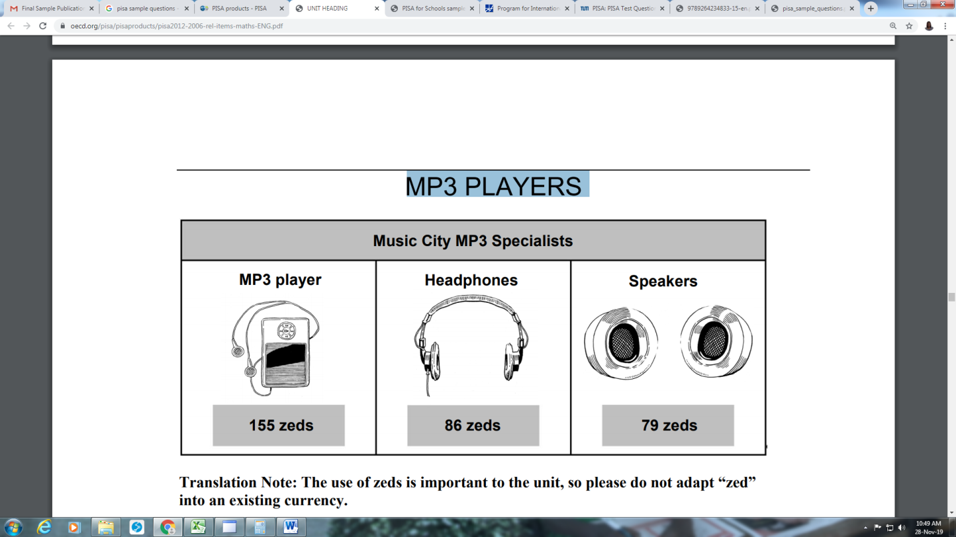

Olivia added the prices for the MP3 player, the headphones and the speakers on her calculator. The answer she got was 248.
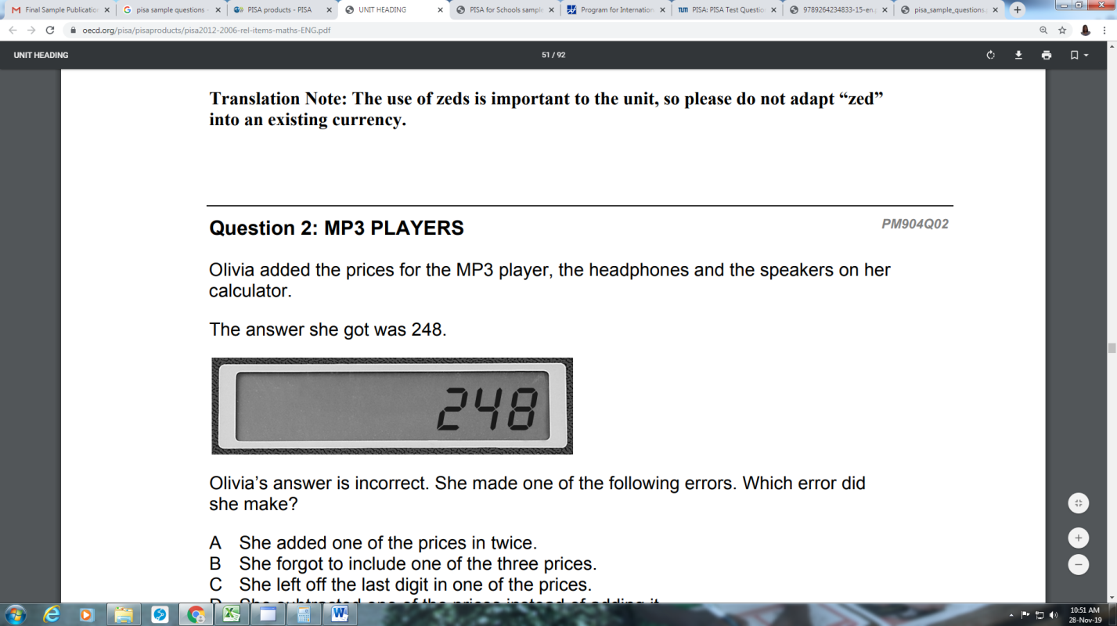

Question
- Olivia’s answer is incorrect. She made one of the following errors. Which error did she make?

- She added one of the prices in twice.
- She forgot to include one of the three prices.
- She left off the last digit in one of the prices.
- She subtracted one of the prices instead of adding it.

MATHEMATICS: SAMPLE ITEM #6
MP3 PLAYERS

Question
- Music City has a sale. When you buy two or more items at the sale, Music City takes 20% off the normal selling prices of these items.
Jason has 200 zeds to spend.
At the sale, what can he afford to buy?

Circle “Yes” or “No” for each of the following options.
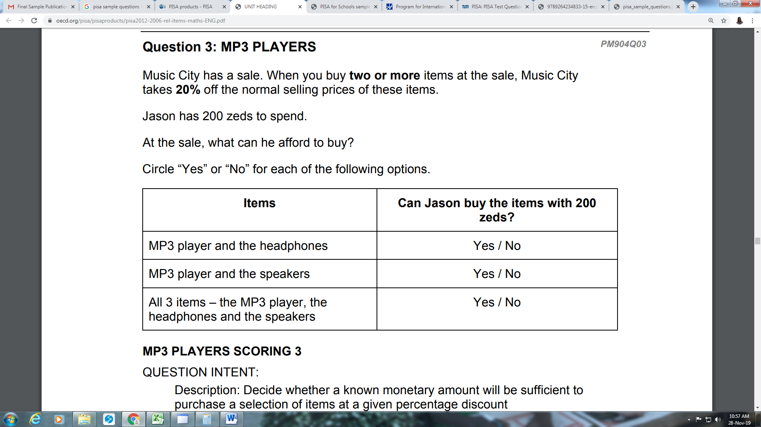

MP3 PLAYERS
Question
- The normal selling price of the MP3 items includes a profit of 37.5%. The price without this profit is called the wholesale price.
The profit is calculated as a percentage of the wholesale price.
Do the formulae below show a correct relationship between wholesale price, w, and normal selling price, s?
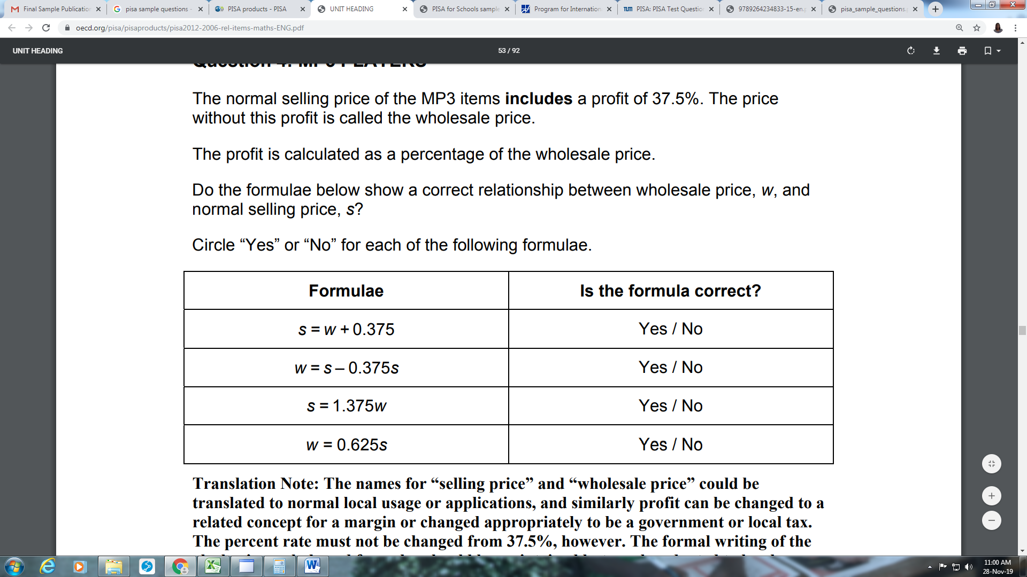
Circle “Yes” or “No” for each of the following formulae.

MATHEMATICS: SAMPLE ITEM #7
OIL SPILL

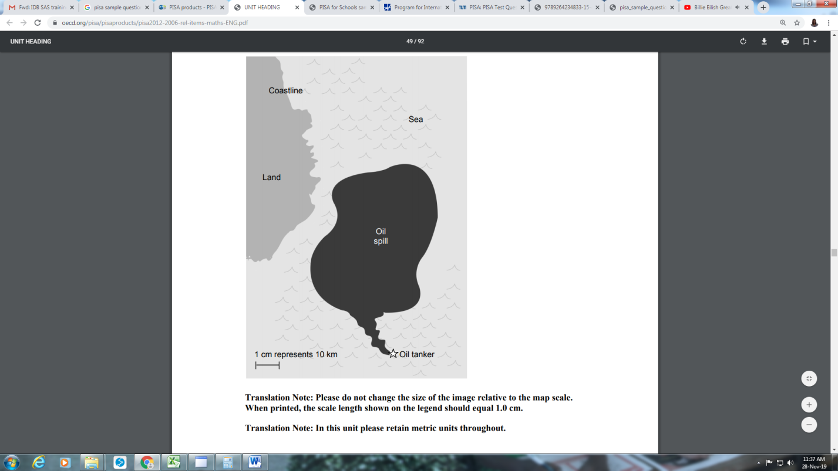
An oil tanker at sea struck a rock, making a hole in the oil storage tanks. The tanker was about 65 km from land. After a number of days the oil had spread, as shown on the map below.

Using the map scale, estimate the area of the oil spill in square kilometres (km²).
Answer: .................................................. km²

MATHEMATICS: SAMPLE ITEM #8
SAILING SHIPS

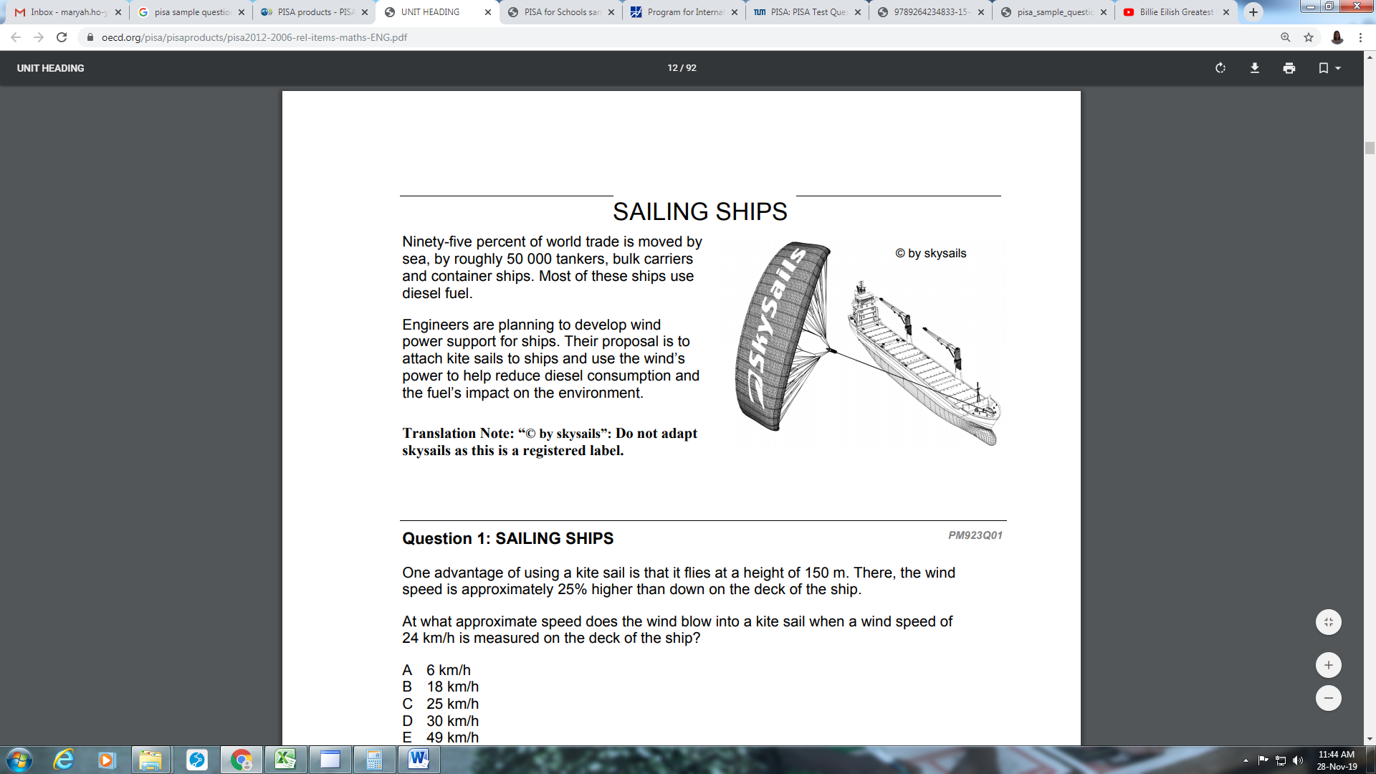
Ninety-five percent of world trade is moved by sea, by roughly 50 000 tankers, bulk carriers and container ships. Most of these ships use diesel fuel.

Engineers are planning to develop wind power support for ships. Their proposal is to attach kite sails to ships and use the wind’s power to help reduce diesel consumption and the fuel’s impact on the environment.

Question

- One advantage of using a kite sail is that it flies at a height of 150 m. There, the wind speed is approximately 25% higher than down on the deck of the ship.
At what approximate speed does the wind blow into a kite sail when a wind speed of 24 km/h is measured on the deck of the ship?
- 6 km/h
- 18 km/h
- 25 km/h
- 30 km/h
- 49 km/h

MATHEMATICS: SAMPLE ITEM #8
SAILING SHIPS

Question
- Approximately what is the length of the rope for the kite sail, in order to pull the ship at an angle of 45° and be at a vertical height of 150 m, as shown in the diagram below?
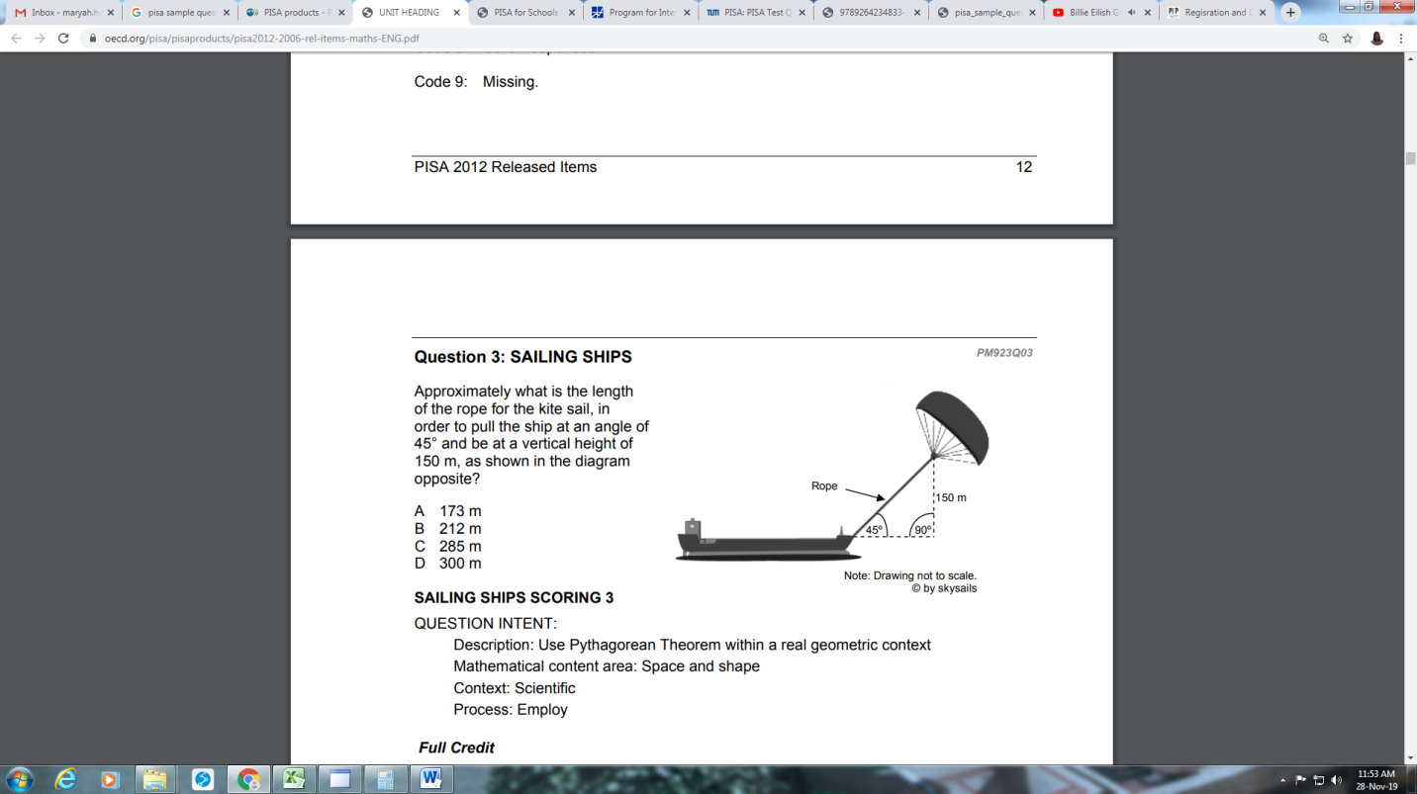

A) 173 m
B) 212 m
C) 285 m
D) 300 m

Question

MATHEMATICS: SAMPLE ITEM #8
SAILING SHIPS

Due to high diesel fuel costs of 0.42 zeds per litre, the owners of the ship NewWave are thinking about equipping their ship with a kite sail.

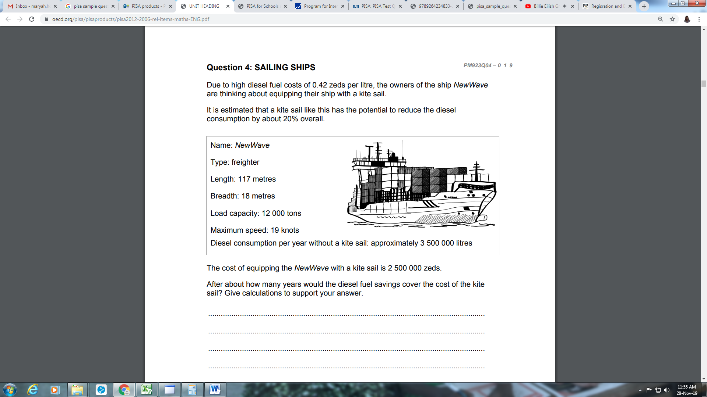
It is estimated that a kite sail like this has the potential to reduce the diesel consumption by about 20% overall.

The cost of equipping the NewWave with a kite sail is 2 500 000 zeds. After about how many years would the diesel fuel savings cover the cost of the kite sail? Give calculations to support your answer. ................................................................................................................................... ................................................................................................................................... ................................................................................................................................... ................................................................................................................................... ................................................................................................................................... ...................................................................................................................................
Number of years: .....................................

SCIENCE: SAMPLE ITEM #1
REVERSE OSMOSIS

One way of producing drinking water from seawater is by reverse osmosis.
Reverse osmosis is a type of filtration.
Seawater is pushed through a semi-permeable membrane. Pressure is applied to the seawater. Semi-permeable means salt is trapped on one side of the membrane, but water can pass through.
The trapped salts form a ‘seawater concentrate’ on one side of the membrane.
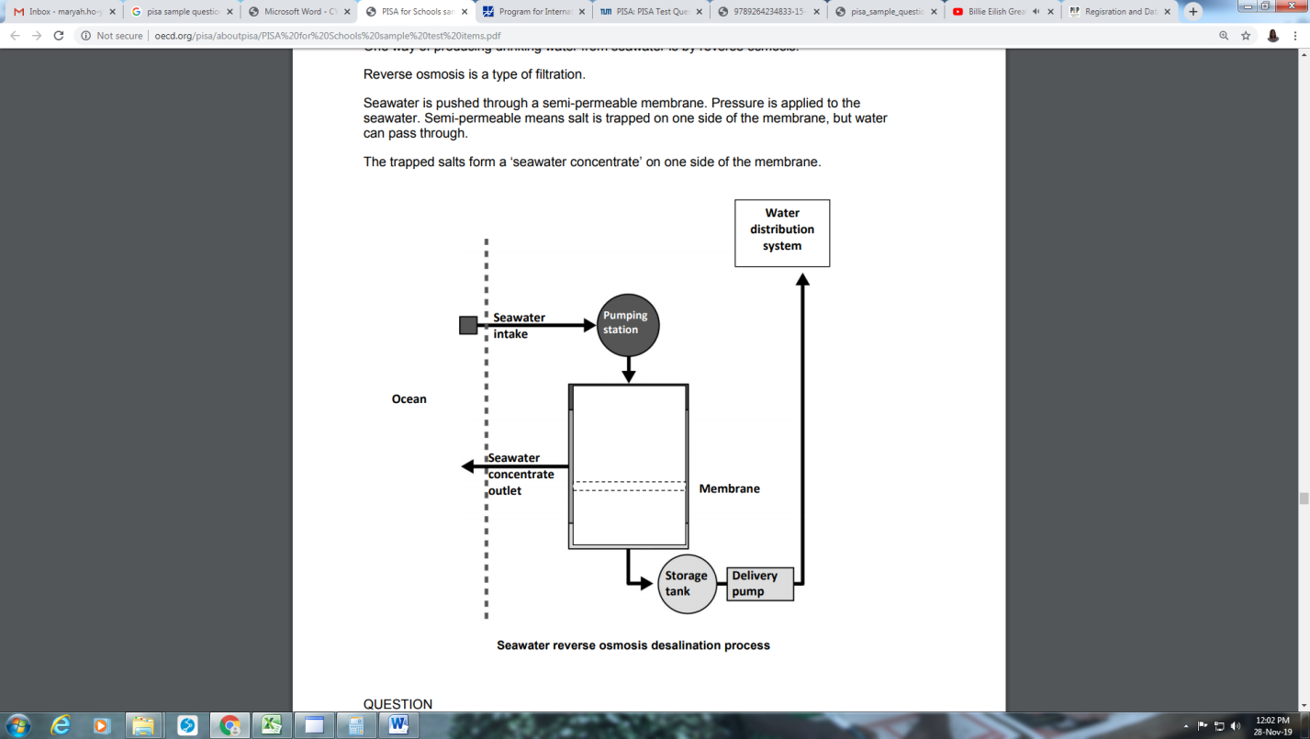

SCIENCE: SAMPLE ITEM #1
REVERSE OSMOSIS

Questions
- Where do the trapped salts go?
  - ocean
  - delivery pipeline
  - storage tank
  - water distribution system

- What will determine whether a particle is able to pass through the membrane?
- particle size
- particle mass
- number of particles
- charge on the particle

SCIENCE: SAMPLE ITEM #2
CHOLERA

Cholera is a disease caused by bacteria. The symptoms are severe diarrhoea and vomiting.
In August of 1854, there was a cholera epidemic in London. At the time it was assumed that cholera was airborne and caused by ‘bad air’. John Snow, a British doctor didn’t believe this theory.
Snow studied the pattern of deaths from the disease. He plotted a map of the affected area, marking the location of every person that died from cholera.
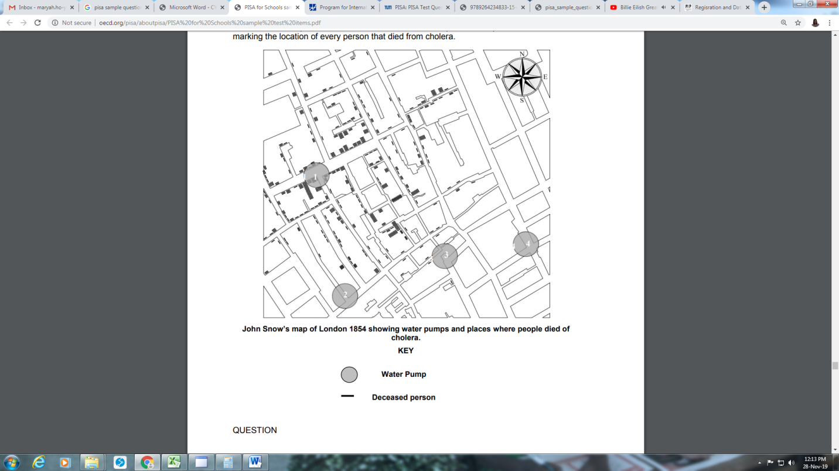

SCIENCE: SAMPLE ITEM #2
CHOLERA

CHOLERA

Question

What further research could John Snow have done to help find out how cholera spread?

Select “Yes” or “No” for the statements about further research.
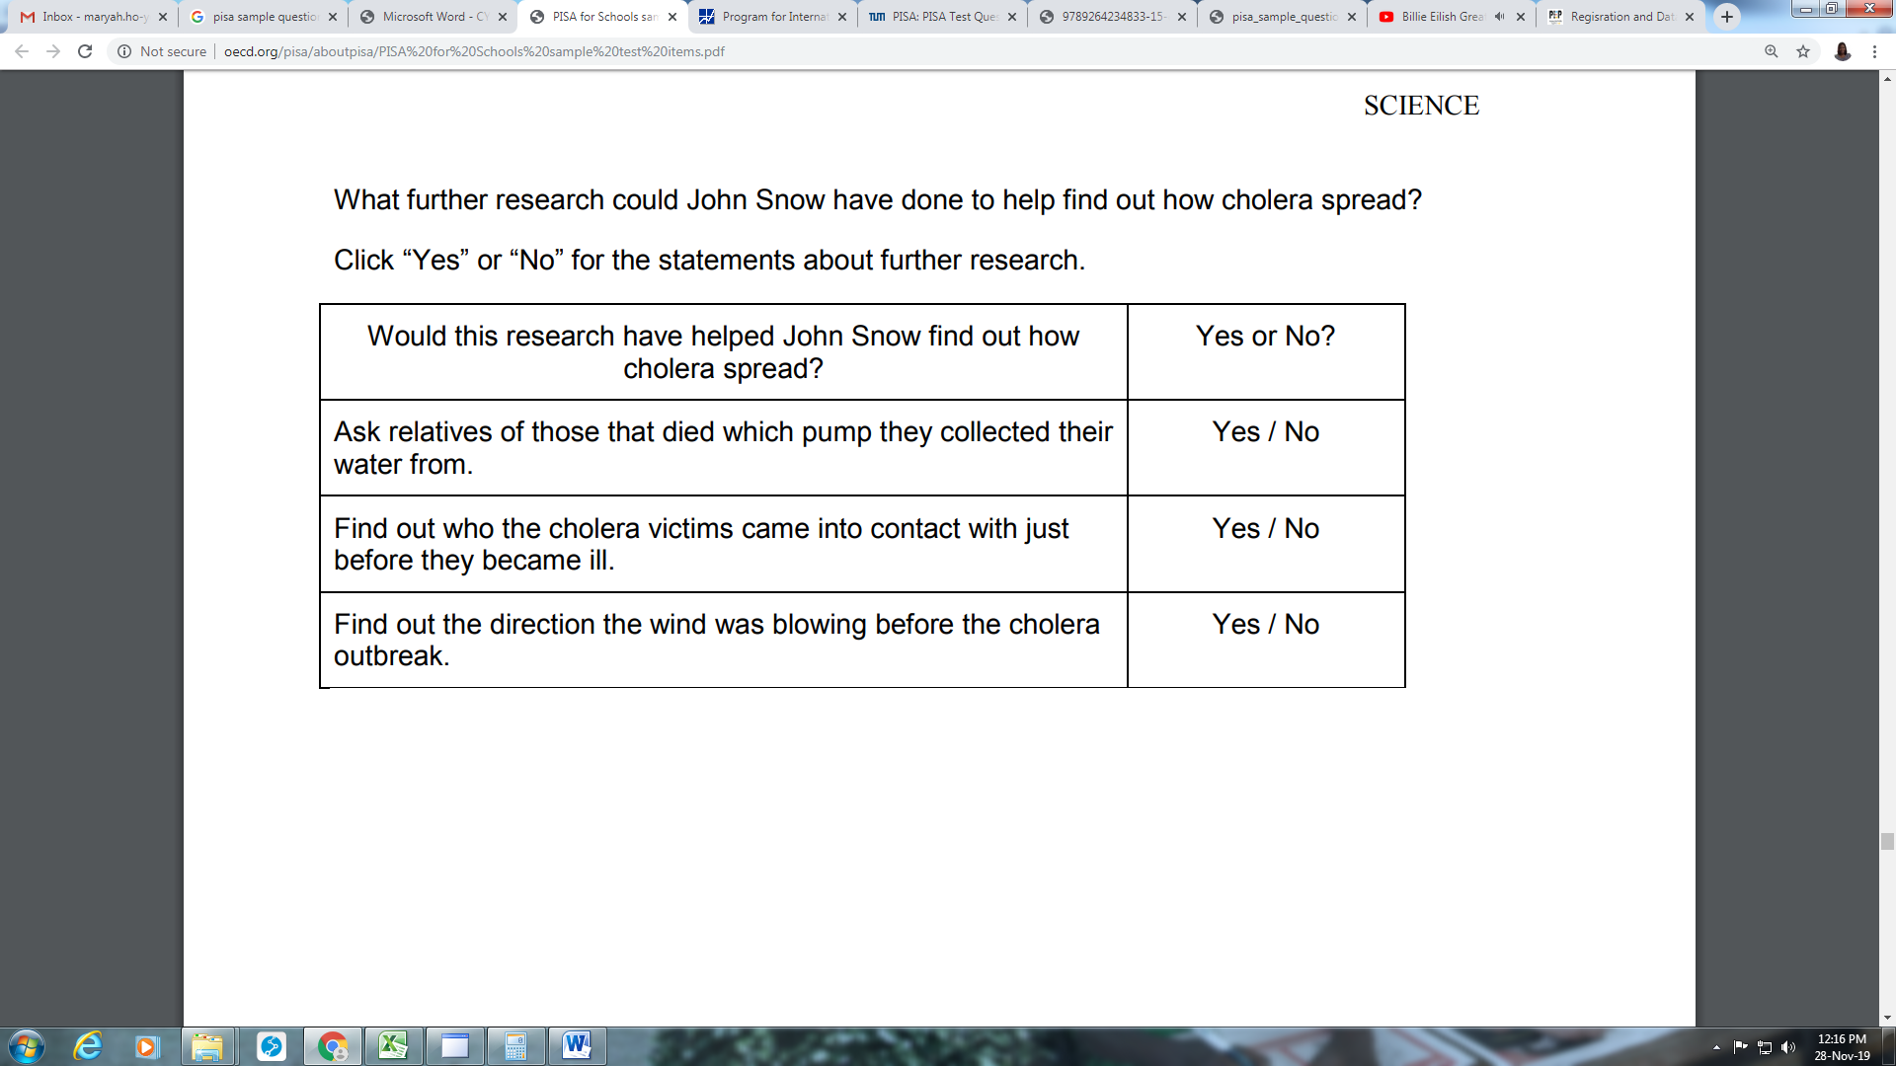

SCIENCE: SAMPLE ITEM #3
HYDROPONICS

Hydroponics is a way of growing plants without soil. The plants grow in an insoluble porous material, e.g. sand, which is regularly soaked with water.
A simple hydroponics system is shown below
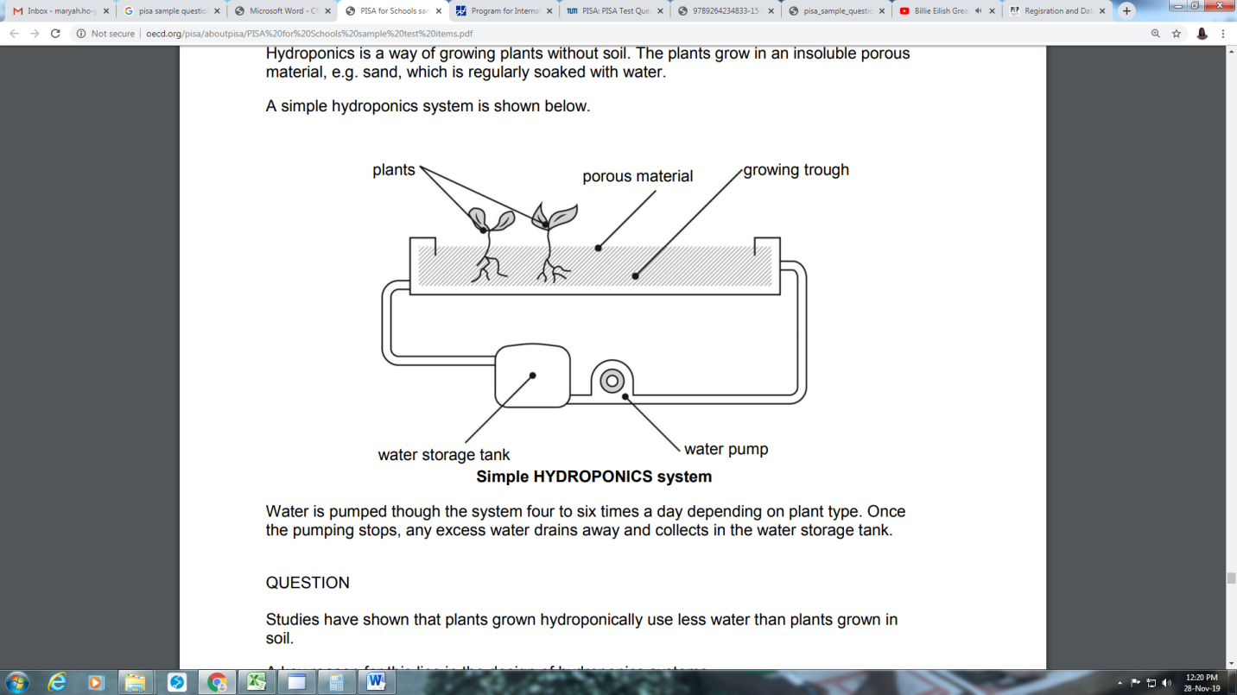

Water is pumped though the system four to six times a day depending on plant type. Once the pumping stops, any excess water drains away and collects in the water storage tank.
Studies have shown that plants grown hydroponically use less water than plants grown in soil. A key reason for this lies in the design of hydroponics systems.
What feature of the hydroponics system saves water compared to plants grown in soil?

Question
- The porous material holds the water in the growing trough.
- Because water is not present all the time there is less evaporation.
- Plants watered at regular intervals absorb less water.
- Water flow over the roots cools the plant, so the plant uses less water.

SCIENCE: SAMPLE ITEM #4
FLOATING

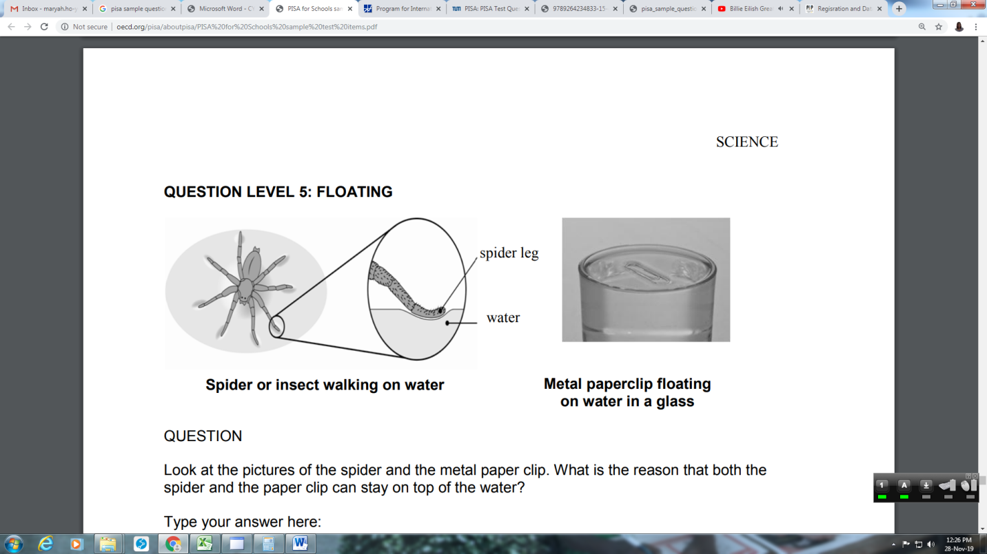

Question

Look at the pictures of the spider and the metal paper clip. What is the reason that both the spider and the paper clip can stay on top of the water?

Write your answer here:
................................................................................................................................... ................................................................................................................................... ................................................................................................................................... ................................................................................................................................... ................................................................................................................................... ................................................................................................................................... ...................................................................................................................................

SCIENCE: SAMPLE ITEM #5
UNDERGROUND COOLING

Most underground train systems have a problem of high temperatures within sections of their tunnels. For example, the London underground has several sections of rail line where the tunnel temperature can be above 40 °C.
The problem has become worse over the past 100 years as soil around the tunnels has gradually warmed.

Question
Which of these heat sources could have contributed to warming soil around the tunnels deep underground?
Select “Yes” or “No” in each case.
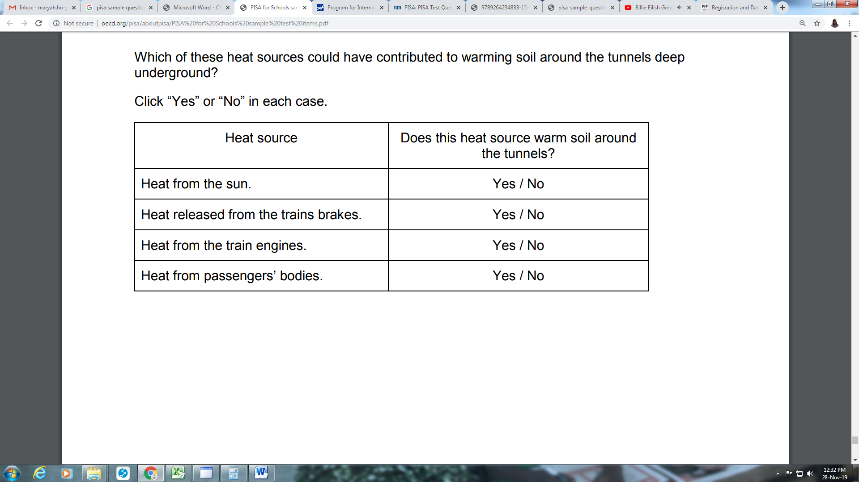

READING: SAMPLE ITEM #1
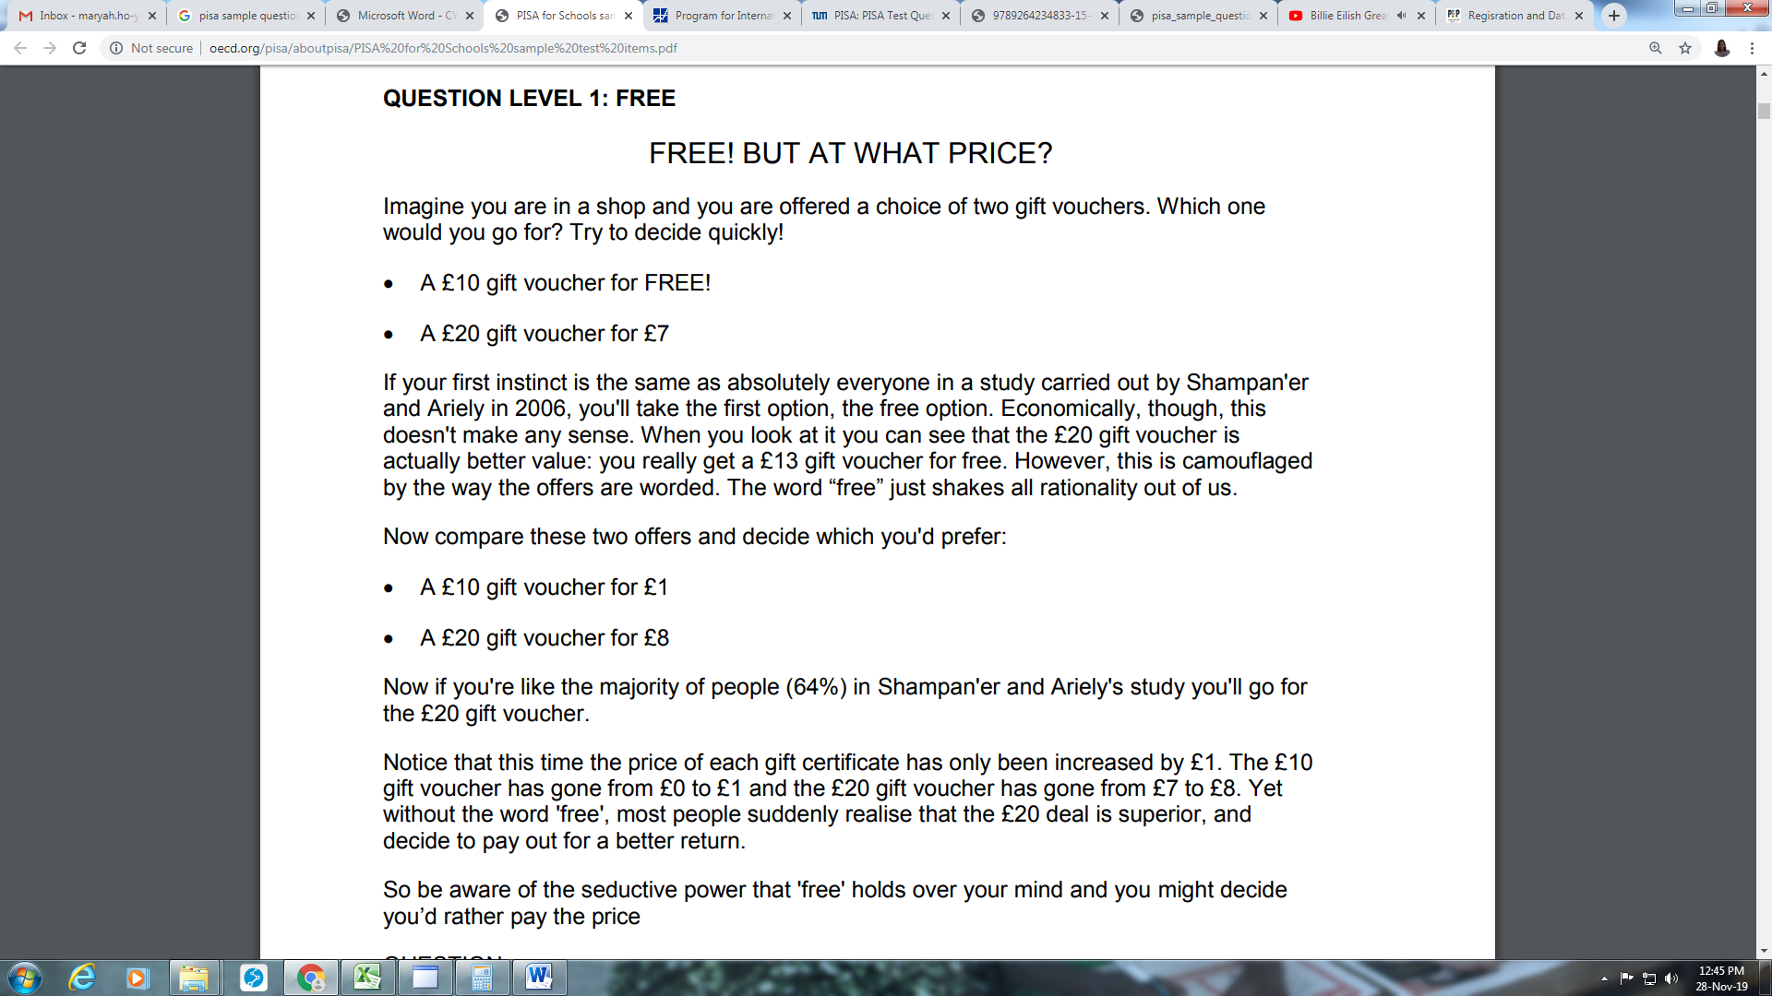

According to the text, what effect does the word “free” have on consumers’ ability to make decisions?

- It prevents them from making decisions.
- It slows down their decision-making.
- It makes their decisions more thoughtful.
- It makes their decisions less thoughtful.

READING: SAMPLE ITEM #2

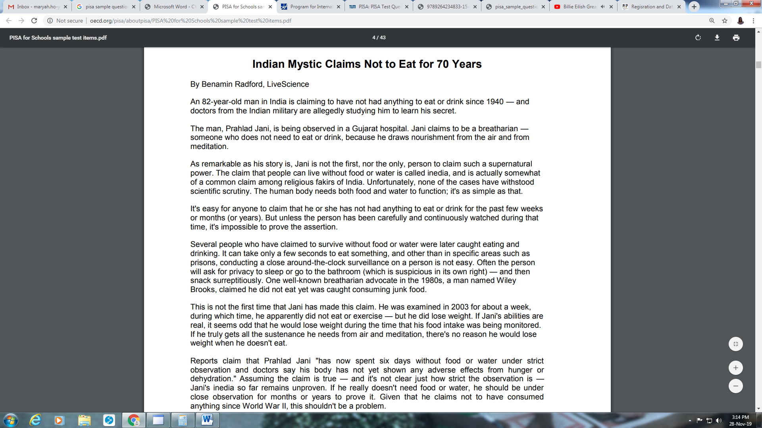
What is the author’s attitude towards the idea that people can survive without food and water? Give a reason for your answer by using information from the article.

READING: SAMPLE ITEM #3

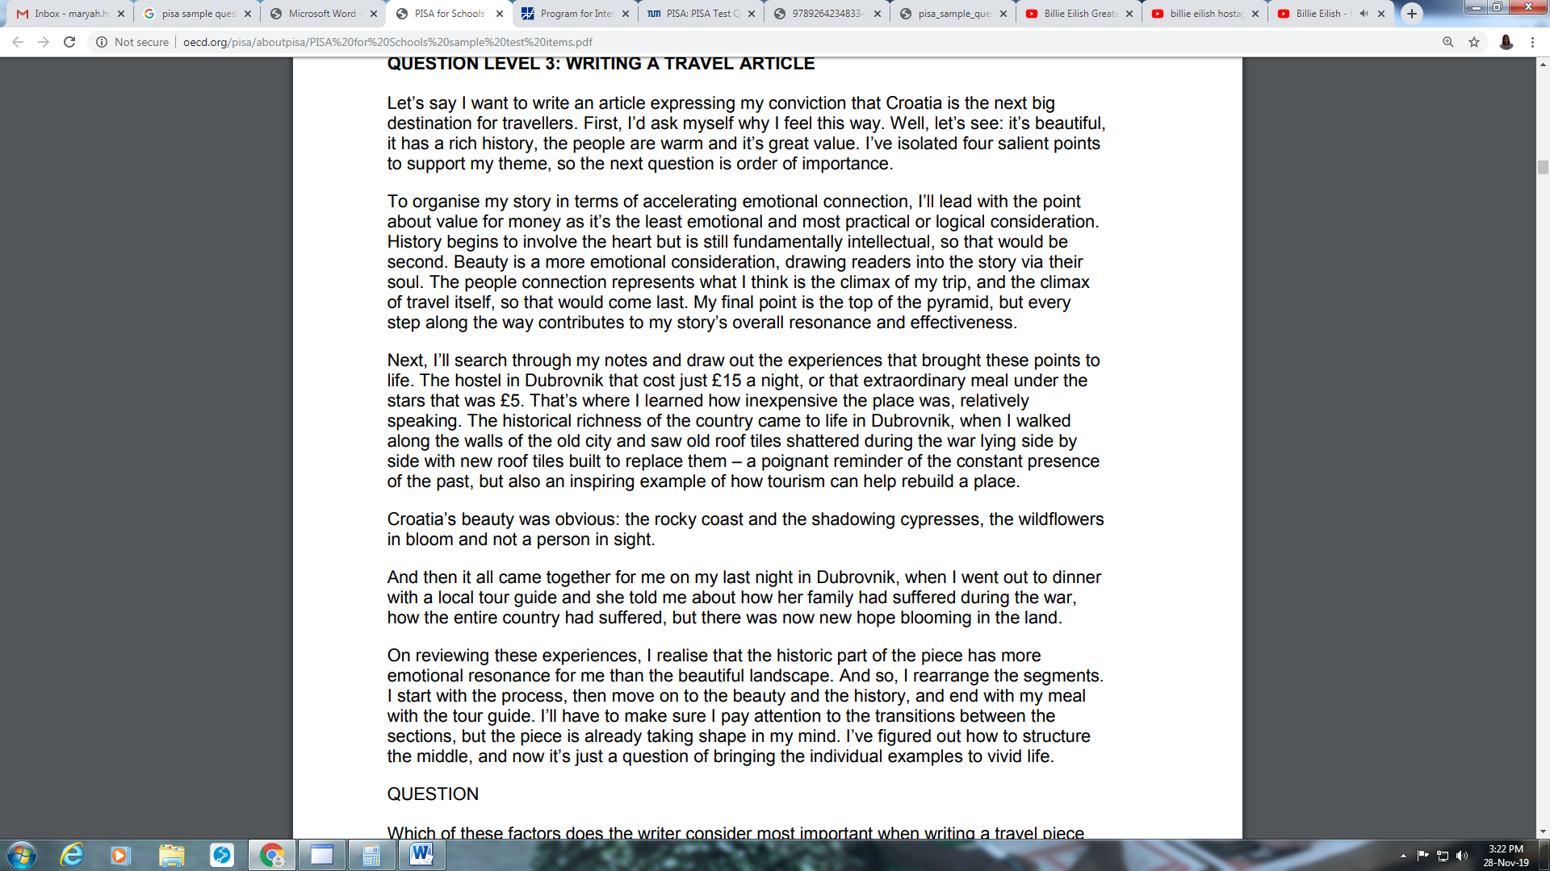
Which of these factors does the writer consider most important when writing a travel piece about Croatia?
- The amount of detail that is provided for each personal story.
- The extent to which each experience described was personally moving.
- The way that the story moves between history and the present day.
- The way that the story links the distressing and rewarding experiences.

READING: SAMPLE ITEM #4
WELL-BEING IN THE UNITED STATES

In 2008, a survey investigated the well-being of people in the United States in relation to their age. The telephone survey involved more than 340,000 people, aged from 18 to 85. The figures below show some of the results.
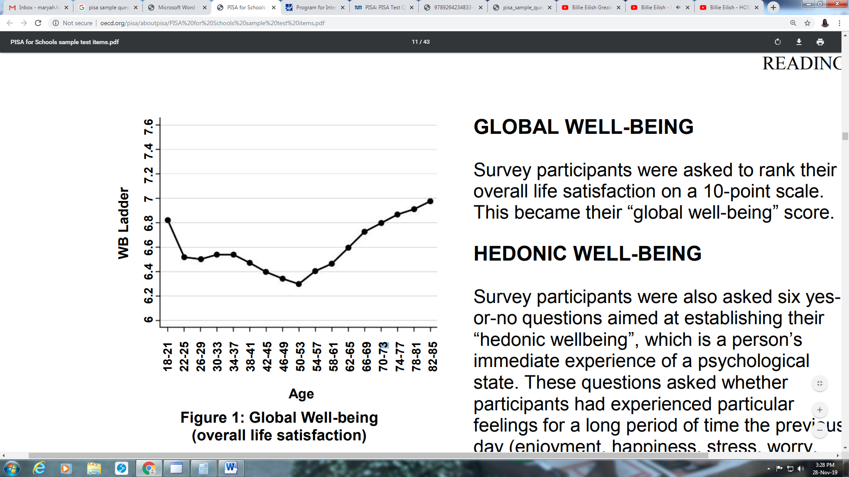
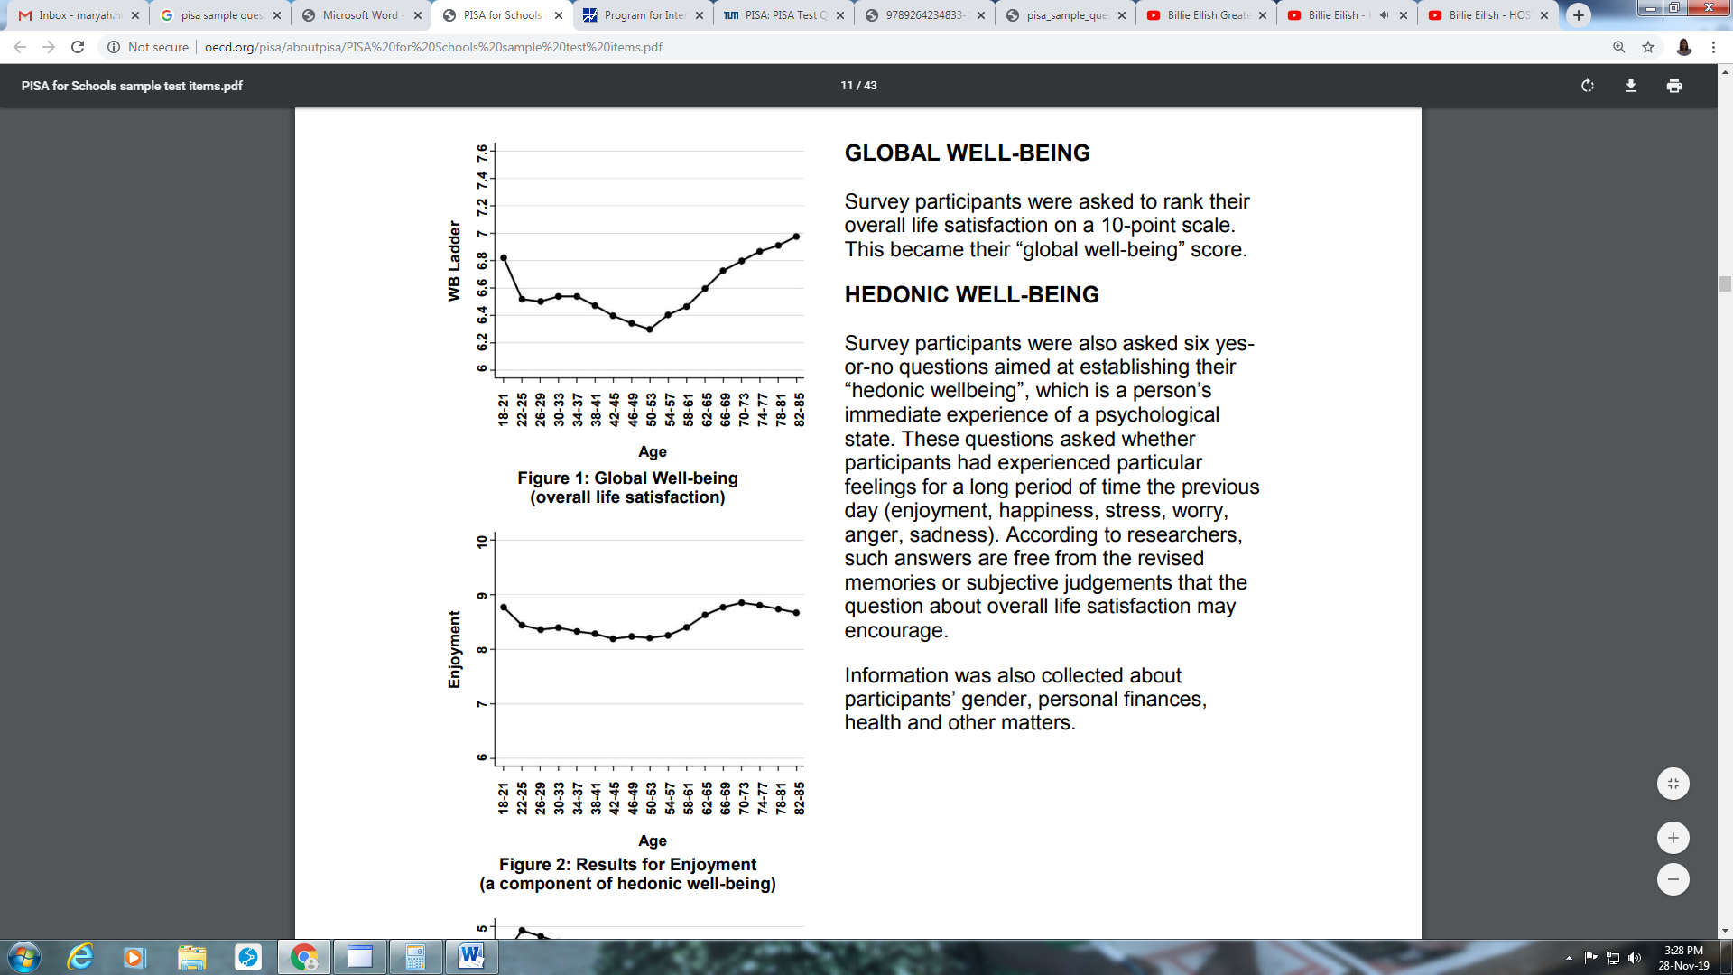

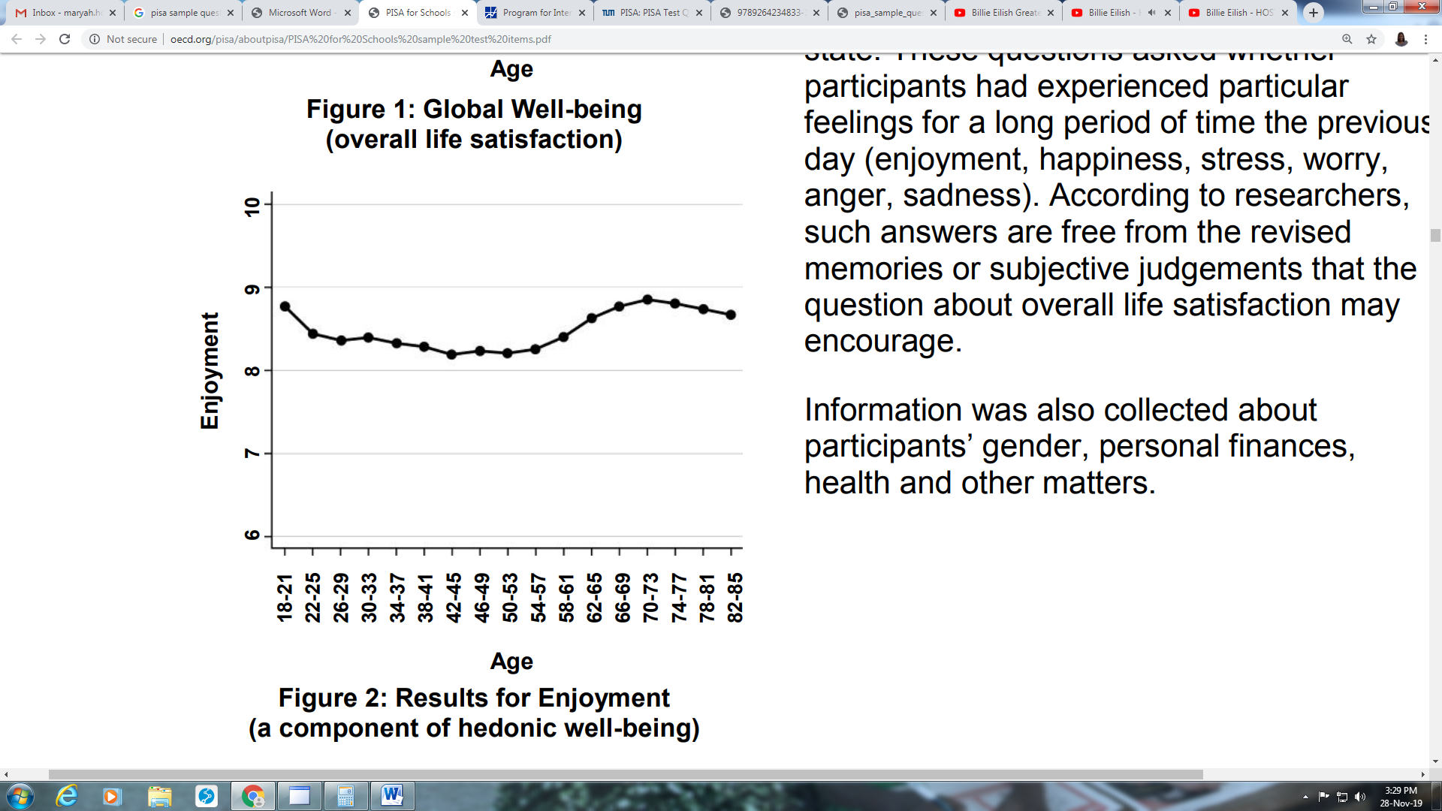

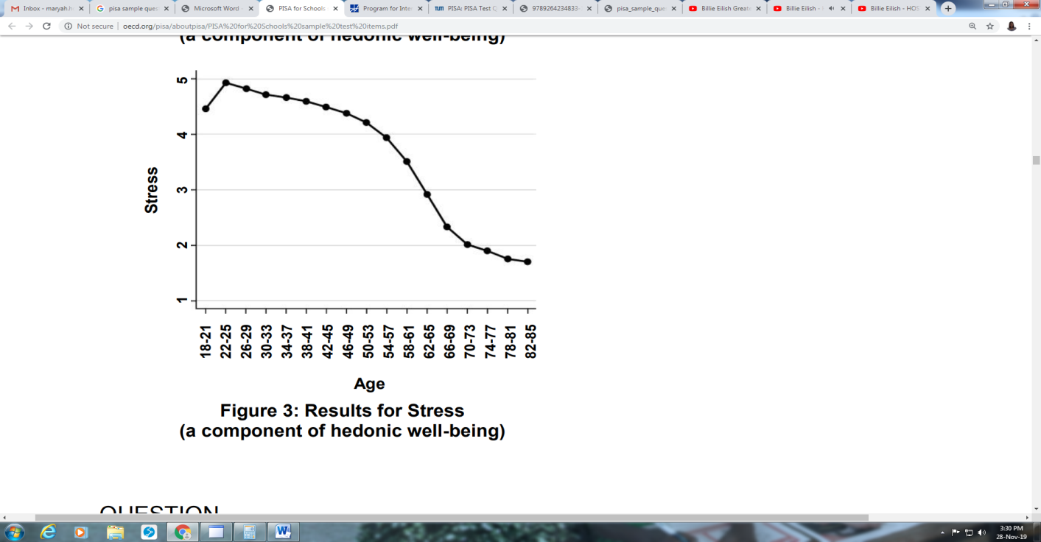

READING: SAMPLE ITEM #4
WELL-BEING IN THE UNITED STATES

Question 1

In order to get the information shown in Figure 3, which of these questions might the researchers have asked the participants during the telephone survey?
- On a scale of 1 to 10, how much stress did you experience yesterday?
- At what time of the day yesterday did you experience stress?
- Did you experience stress for a large part of the day yesterday?
- At what age did you experience most stress?

READING: SAMPLE ITEM #4
WELL-BEING IN THE UNITED STATES

Question 2

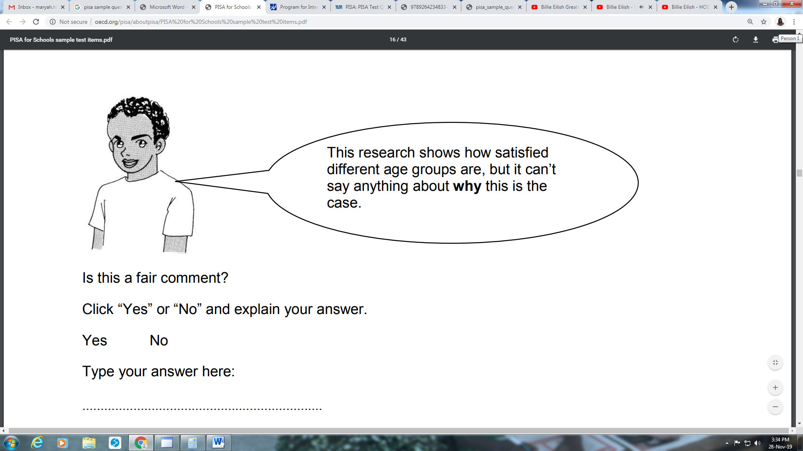

Is this a fair comment?
Indicate “Yes” or “No” and explain your answer.
................................................................................................................................... ................................................................................................................................... ................................................................................................................................... ................................................................................................................................... ...................................................................................................................................

CREATIVE THINKING: SAMPLE ITEM #1
BICYCLE OF THE FUTURE

PART 1
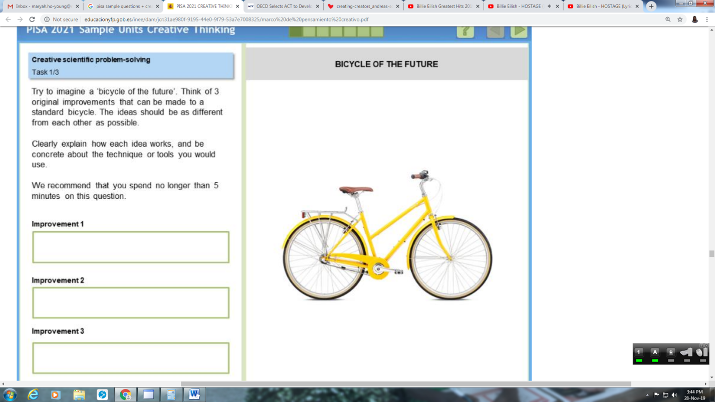
Try to imagine a “bicycle in the future”. Think of 3 original improvements that can be made to a standard bicycle. The ideas should be as different from each other as possible.

Clearly explain how each idea works, and be concrete about the technique or tools you would use.

We recommend you spend no longer than 5 minutes on this question.

PART 2

Improvement 1
Improvement 2
Improvement 3
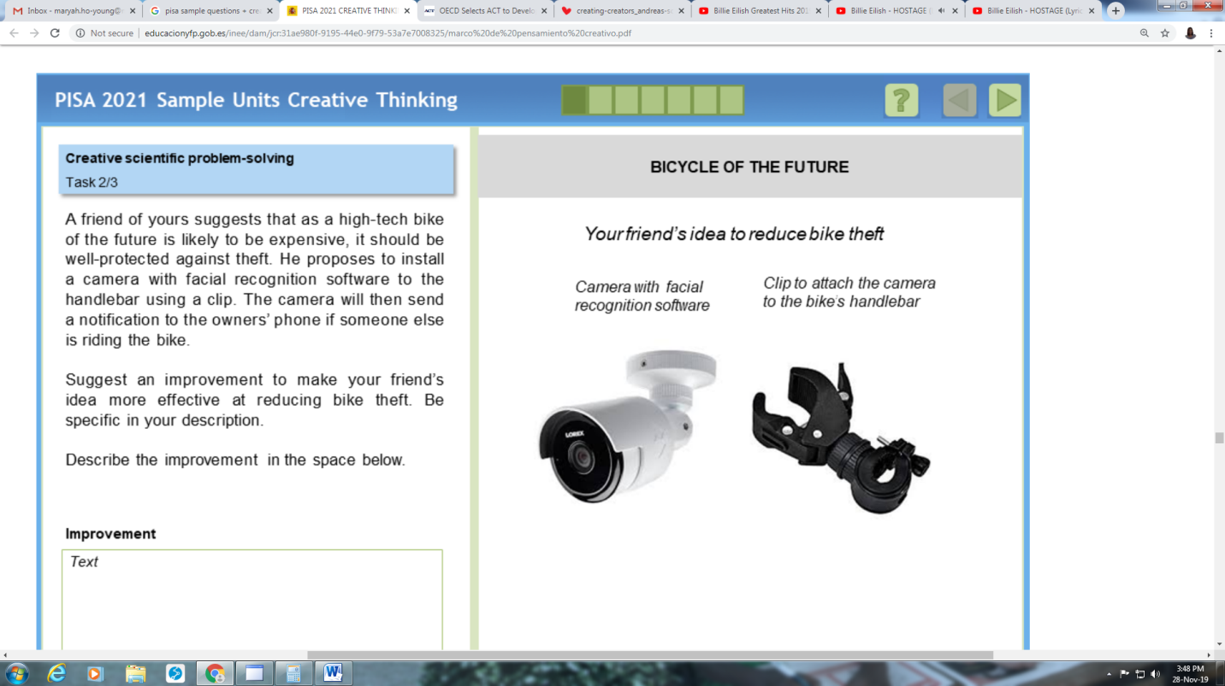

A friend of yours suggests that as a high-tech bike of the future is likely to be expensive, it should be well-protected against theft. He proposes to install a camera with facial recognition software to the handlebar using a clip. The camera will then send a notification to the owner’s phone if someone else is riding the bike.
Suggest an improvement to make to your friend’s idea more effective at reducing bike theft. Be specific in your description.
Describe the improvement in the space below.

PART 3

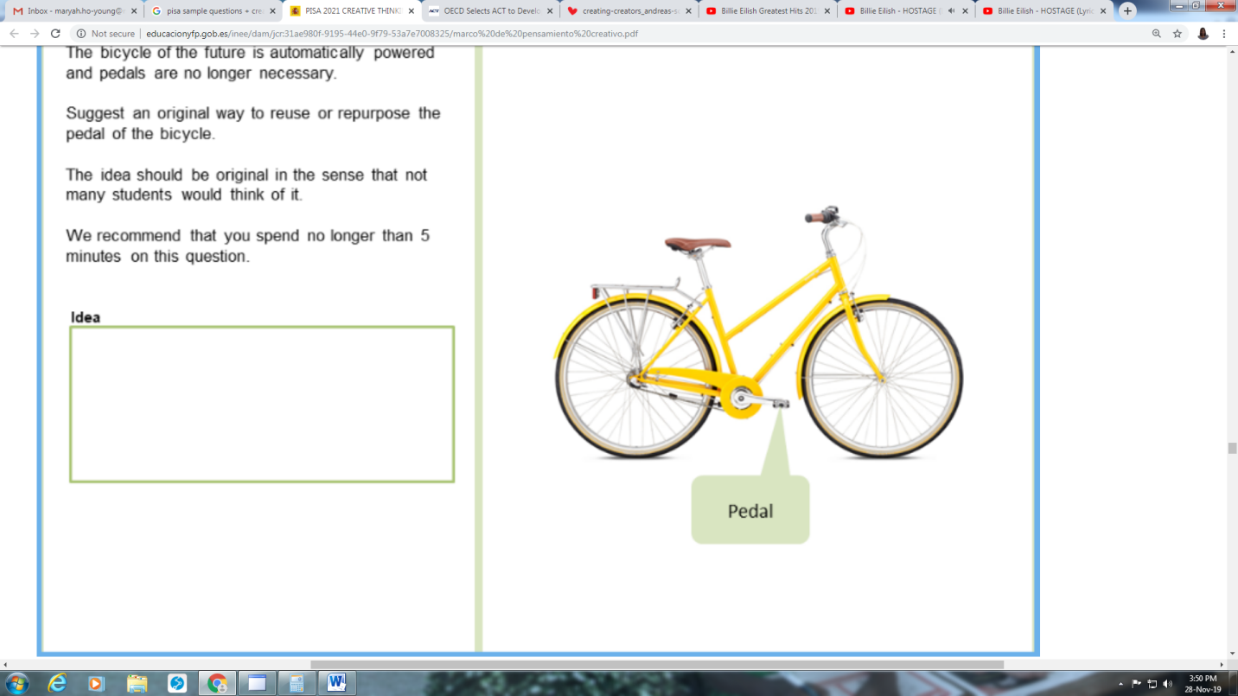

The bicycle of the future is automatically powered and pedals are no longer necessary.
Suggest an original way to reuse or repurpose the pedal of the bicycle.
The idea should be original in the sense that not many students would think of it.
We recommend that you spend no longer than 5 minutes on this question.

REFERENCES

OECD (2019), Framework for the Assessment of Creative Thinking in PISA 2021: Third Draft, Organisation for Economic Co-Operation and Development, http://www.educacionyfp.gob.es/inee/dam/jcr:31ae980f-9195-44e0-9f79-53a7e7008325/marco%20de%20pensamiento%20creativo.pdf (accessed on 28 November 2019).

OECD (2019), PISA 2021 Integrated Design, Organisation for Economic Co-Operation and Development, https://www.oecd.org/pisa/pisaproducts/PISA2021_IntegratedDesign.pdf(accessed on 28 November 2019).

PISA (2009), PISA Take the Test: Sample Questions from the OECD’s PISA Assessments, Organisation for Economic Co-Operation and Development, https://www.oecd.org/pisa/pisaproducts/pisatakethetestsamplequestionsfromoecdspisaassessments.htm (accessed on 28 November 2019).

